Sample ESSER Funds Grant Application
Description: Airflow and ventilation are an important part of keeping students healthy and safe this year. The Department of Education and the Centers for Disease Control have both identified carbon dioxide monitoring as a way in which to measure the airflow within indoor spaces. According to the Centers for Disease Control, CO₂ levels can be used as a proxy to measure how clean indoor air is. Every time someone exhales, speaks, sings etc., CO₂ is released into the air. As CO₂ levels rise in closed spaces with poor ventilation, so does the air exhaled by someone else in the room (aka “shared air”). Research has shown that as the levels of CO₂ rise, there are greater levels of “shared air” and increased risks of transmission of airborne viruses (e.g. COVID-19, influenza, whooping cough). Measuring CO₂ levels allows school administrators and staff to get an objective, data-based measure of indoor airflow in classrooms or other shared spaces. Keep school staff and students safe by monitoring indoor air and acting quickly to improve air quality.

Proposed Solution: Carbon Dioxide monitoring can provide real-time information about the levels of carbon dioxide in rooms. We are asking for XXX CO₂ Check monitors, as well as XXX network plug and go solutions, so that we can start to immediately monitor our indoor spaces (Figure 1). The plug and go solutions are completely external to the school’s network, with their own wi-fi hot spot, cellular service, and devices which are connected via wi-fi. There is a central remote trend monitoring dashboard on a mobile phone app, as well as a desktop mobile-ready version which can be displayed online, through a monitor, and/or accessed via QR code and made accessible to anyone who would like to follow real-time CO₂ level trend tracking.
Why CO₂ Check: CO₂ Check provides low-cost monitors with real-time visual display of CO₂ levels. It also has the ability to connect to a completely separate network solution that operates externally from the school’s wi-fi network. Supported by a mobile hotspot with cellular service and wi-fi capabilities, the network is extended using a series of mesh nodes that allows for complete coverage of the school. No other monitor currently allows for visual display, portable CO₂ devices, as well as the ability to plug and go immediately so that these networks can be shifted from school to school with ease. Very little additional programming will be needed, and schools/parents/facilities’ managers, and/or superintendents can watch these levels in real-time. Other devices have some of these capabilities, but not all, which is why we are requesting these monitors and networks specifically.
ESSER Fund eligibility: Per the Department of Education Section of the American Rescue Plan, CO₂ monitoring devices “are eligible for funds to improve indoor air quality for in-person learning.”

Figure 1: Sample Mesh Network Configuration to Cover Whole School
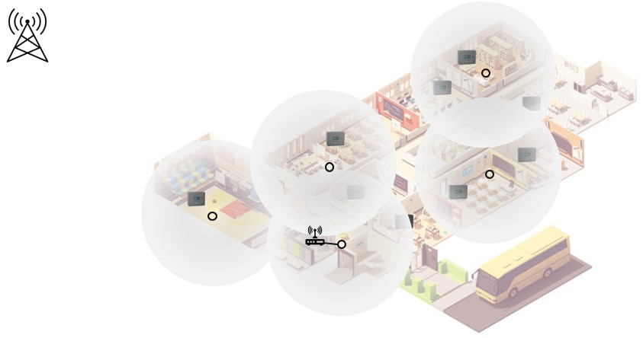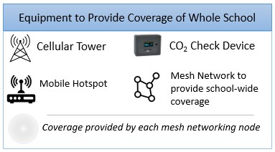

Purchasing Details: All devices and networks can be obligated by the deadline of September 30th, 2022, and a purchase order can be issued immediately. Please support our woman-owned, minority business that is registered in the SAM.gov site. Do not let your ESSER funds go unused!
DPS Educational Package Pricing Details
Package 1 | Platinum | Educational Discount
Hot Spot | $365 | 10%
Cell Monthly ($101.25/month*12) | $1,215 | 10%
Mesh Network (3 Nodes) | $206.25 | 10%
Additional Nodes (1) | $106.25 | 10%
Tablet | $300 | 10%
Tech Assistance/Data Storage Space ($10/month) | $120 | 10%
10 CO₂ Check Devices | $1,690 | 10%
10 USB Plugs | $50 | 10%
Wall Adhesives | $10 | 10%
TOTAL | $4,062.50 | $3,656.25
Package 2 | $3,626.25 | $3,263.60
Network with Hot Spot, Cell Service (9 months), Mesh Network, Tech Assistance/Data Storage, 10 CO₂ Check Devices, 10 USB Plugs, Wall Adhesives
*9 months instead of 12 months of cell service & data storage, no tablet, no extra node
Additional Information at www.co2check.com
Y4 Options to Connect Your Remote Trend Monitoring System
Option 1: Wirelessly connect CO₂ Check devices directly to your network
Option 2: Add mesh network to increase your connectivity for multiple devices. (Silver Package)
Option 3: Ready-to-use option for small spaces (Gold Package)
Option 4: Ready-to-use option for large spaces (Platinum Package)

Packages Available
 | Platinum | Gold | Silver
Mobile Hot Spot | x | X
Mesh Network (comes with 3 nodes for 5,500 sq ft of coverage) - additional nodes available | x |  | X
Cellular Service (1-, 2-, 3-year options available) | x | X
Tablet for Display | x | x
Technical Assistance | X | X | X
Total Price | $2,145 | $1,865 | $315
Individual Components also available. Call for pricing options. Does not include cost of CO₂ Check devices.

Platinum Package
No need to rely on a school's WiFi network or connect devices via a school's guest network
By utilizing cellular service and mesh networking technology, all of a school's classrooms can have monitors that measure CO₂ levels at all times. The devices are set up separate of a school's WiFi network, so there is no need to clog a school's network or to connect devices via a school's guest network. When levels get too high, our remote monitoring allows a staff member (facilities manager, school administrator, etc.) to get alerts that levels are too high in a classroom.

